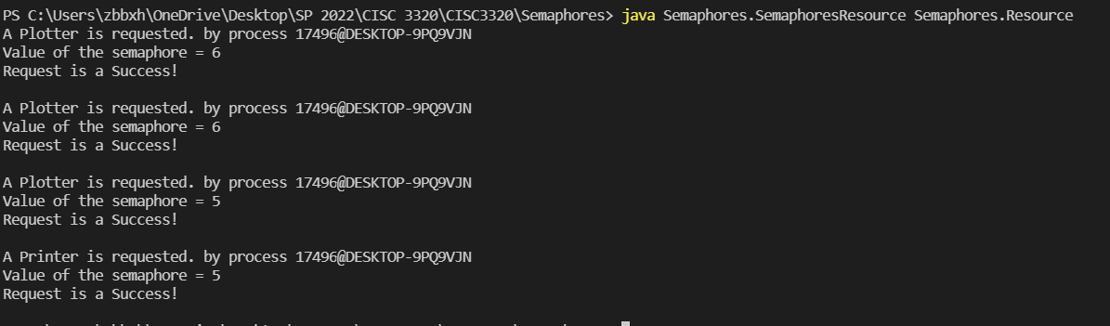

A Plotter is requested. by process 17496@DESKTOP-9PQ9VJN

Value of the semaphore = 6

Request is a Success!

A Plotter is requested. by process 17496@DESKTOP-9PQ9VJN

Value of the semaphore = 6

Request is a Success!

A Plotter is requested. by process 17496@DESKTOP-9PQ9VJN

Value of the semaphore = 5

Request is a Success!

A Printer is requested. by process 17496@DESKTOP-9PQ9VJN

Value of the semaphore = 5

Request is a Success!